Name | Description | Parameters | PMF | Mean | Variance
Bernoulli | Binary random variable | $$p$$ | $$f\left(x\right)=p^{x}{\left(1-p\right)}^{1-x}$$  $$with x = 0, 1$$ | $$p$$ | $$p\left(1-p\right)$$
Binomial | Number of successes from $n$ i.i.d. Bernoulli trials | $$n, p$$ | $${f\left(x\right)=\left(\begin{matrix}n \\ x\end{matrix}\right)p}^{x}{\left(1-p\right)}^{n-x}$$  $$with x = 0, 1, 2, . . . , n$$ | $$np$$ | $$np\left(1-p\right)$$

(Airplane Booking) An airplane has 100 seats. The airline “overbooks” a flight (sells more tickets than available seats) in order to maximize their profit. Assume that each ticket holder’s decision to show up for a flight is an independent Bernoulli trial with a probability of showing up for the flight of 0.92. If the airline profit is $10 for each seat sold and the airline loses $40 for each “bumped” passenger, what is the expected profit if 103 seats are sold?
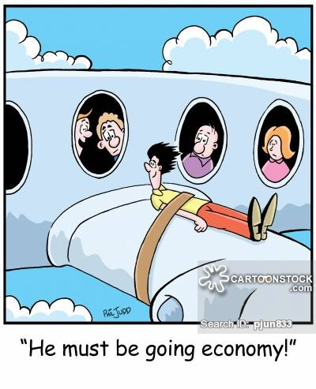
$X=$ # of passengers that show up for a flight
$X$ ∼ binomial(103, 0.92)
$$f\left(x\right)=\left(\begin{matrix}103 \\ x\end{matrix}\right){0.92}^{x}{0.08}^{103-x}$$
where $x=0, 1, 2, . . . , 103$.

The expected profit generated from selling 103 tickets for the flight is
$(103)(10)-40×P(X=101)-80×P(X=102)-120×P(X=103)$.
The probabilities of 101, 102, and 103 customers arriving for the flight are
$$P\left(X=101\right)=f\left(101\right)=\left(\begin{matrix}103 \\ 101\end{matrix}\right){\text{0.92}}^{\text{101}}{0\text{.08}}^{2}$$
$$=\text{ 0.007399}$$
$$P\left(X=102\right)=f\left(102\right)=\left(\begin{matrix}103 \\ 102\end{matrix}\right){\text{0.92}}^{\text{102}}{0\text{.08}}^{1}$$
$$=0.001668$$
$$P\left(X=103\right)=f\left(103\right)=\left(\begin{matrix}103 \\ 103\end{matrix}\right){\text{0.92}}^{\text{103}}{0\text{.08}}^{0}$$
$$=0.0001863$$
$$1030-40P(X=101)-80P(X=102)-120P(X=103)$$
= $1029.55

